1.Title / Content Area: | Teacher, Language Arts | LOGO Alliance Network
2. Developed by: | Name: Kena Taylor  Alliance: Arizona Geographic Alliance
3. Grade Level: | 9
4. National Geography Standards | 15. How physical systems affect human systems.
5. Essential Question | GEOGRAPHY: How does geography, climate and natural resources affect the way people live and work?  Do the arts reflect or shape culture?  ECONOMICS: What does it mean to make a living?
6. Contextual Paragraph | Today’s teens don’t realize the culmination of events and culture that has led to the present lifestyle they lead within their communities. What influenced (location, climate, religion, etc.) their local Cowboy Poetry Festival or Salsa Festival; the beginning of cotton farming, logging, or mining; and early settlement. Also, what would happen to these entertainment and economic staples if the climate changed drastically?  Discussions can branch off to topics like what would be the best evacuation mode for the area in a catastrophe? How would one best survive by staying put?

Annotated Resource Set (ARS)
Phase I
7. Resource Set
Dust Storm. Amarillo, Texas | Oklahoma Family on Highway | Destitute Pea Pickers in California | Family Who Traveled by Freight Train | Arizona | Why We Came to Californy (California)
Dust Bowl | 1936, Forced to abandon farm and head to AZ and CA for field work. Their car had broken down and been abandoned | Mother of seven children. Age thirty-two. Nipomo, CA | During the Dust Bowl | Song about how the Okies ended up in Arizona when they were headed for California | Mrs. Flora Robertson telling a story about Black Kettle’s prophecy
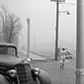 | 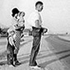 | 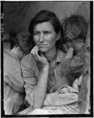 | 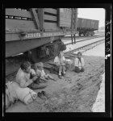
http://www.loc.gov/pictures/item/fsa1998018986/PP/ | http://www.loc.gov/pictures/item/fsa1998021756/PP/ | http://www.loc.gov/pictures/item/fsa1998021539/PP/ | http://www.loc.gov/pictures/item/fsa2000003842/PP/ | http://hdl.loc.gov/loc.afc/afcts.4148a1 | http://hdl.loc.gov/loc.afc/afcts.4120b1

Why We Came to California | Migrant Worker Camp near Harlington, Texas | Camps of migrant pea Workers. California | Slums of Brawley | Vegetable workers, migrants, waiting to be paid | The Migrant Worker
Text of Song | Type of home workers often lived in. | Type of home workers often lived in. | Mexican field workers’ homes. Imperial Valley, California. | Near Homestead, Florida | Song by Jim Croce
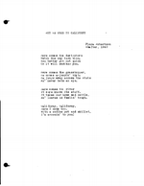 | 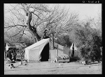 | 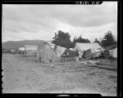 | 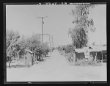 | 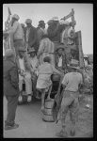
http://hdl.loc.gov/loc.afc/afcts.st116 | http://hdl.loc.gov/loc.pnp/fsa.8b37319 | http://hdl.loc.gov/loc.pnp/fsa.8b27084 | http://hdl.loc.gov/loc.pnp/fsa.8b29593 | http://hdl.loc.gov/loc.pnp/fsa.8a40711 | https://www.youtube.com/watch?v=QO5BKuSz5iA

Notes/Comments:
Phase II
Foundations Annotations
8. Cross-Curricular Connections:
1.
Writing Standards: “Write arguments to support claims with clear reasons and relevant evidence.” 9.W.1

9. Standards (District, State, C3, National, or Other Standards)
D2.Geo.7.9-12. Analyze the reciprocal nature of how historical events and the spatial diffusion of ideas, technologies, and cultural practices have influenced migration patterns and the distribution of human population.
D2. Geo.9.9-12. Evaluate the influence of long-term climate variability on human migration and settlement patterns, resource use, and land uses at local-to-global scales.
D2.His.1.9-12. Evaluate how historical events and developments were shaped by unique circumstances of time and place as well as broader historical contexts.
8.W.1. Write arguments to support claims with clear reasons and relevant evidence.

10. Objectives
The purpose of this activity is to have kids think critically about their surroundings and how much of their livelihood depends on crops grown in the area or the weather conditions or nearby industry. Based on the study of The Dust Bowl and its effects, students should have a guide for their research on the settlement history of their own town and identify the local arts festivities influenced by their local culture. Students should be able to write an argument where they make a claim

11. Inquiry Activities & Teaching Strategies
1. Make a list of local industry, cultural traditions, and reasons for settlement in your own community. Identify the geographical influences that most accommodate each item on the list.
2. Write an essay that answers the following question: How would local industry, population, and culture be affected if the climate experienced an abrupt change like that of the Dust Bowl in the Mid-West in the 1930s. Use strong evidence to support your claims.

12. Assessment Strategies

Grade the essay based on a rubric with categories such as organization and critical thinking.

Other Resources
13. Web Resources
Library of Congress at loc.gov
YouTube at youtube.com

14. Secondary Sources

15. Print and Other Media Resources

