1.Title / Content Area: | Immigration to the United States
2. Developed by: | Matthew Laskin
3. Grade Level: | 7th
4. Geographic Thinking Skill(s): | S1 How to use maps and other geographic representations, tools, and technologies to acquire, process, and report information from a spatial perspective.  S6 How culture and experience influence people’s perceptions of places and regions.  S9 The characteristics, distribution, and migration of human populations on Earth’s surface.  S12 The processes, patterns and functions of human settlement.
5. Essential Question: | Why do people move from one place to another?
6. Contextual Paragraph (Connect to Geographic Thinking) | In the late 19th century following the Civil War, a vast wave of immigration hit the United States. These immigrants came from many different areas around the world, and in some cases, these areas were different than had previously been immigrating to the United States. There were many push/pull factors that brought these people to the United States.  This wave of immigration helped to create a new culture in the United States through the process of assimilation and the “melting pot” effect. As people entered the United States, they adopted the culture of the country while adding their own culture to the mix.

Annotated Resource Set (ARS)
Phase I
6. Resource Set
Steerage Passengers Taking Life Easy on an Ocean Liner | View of Ellis Island, NY | Immigration station, Angel Island, CA | Immigration Figures for 1903 | Distribution of the foreign born population of the United States: 1890 | Foreign born population, by States and Territories: 1890
B&W Photograph  c. 1905 | B&W Photograph  c. 1913 | B&W Photograph  c. 1915 | Publication of the Immigration Restriction League | Map | Graph
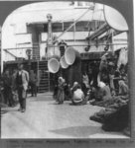 | 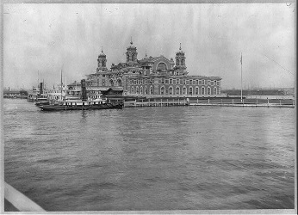 | 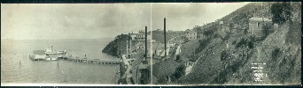 | 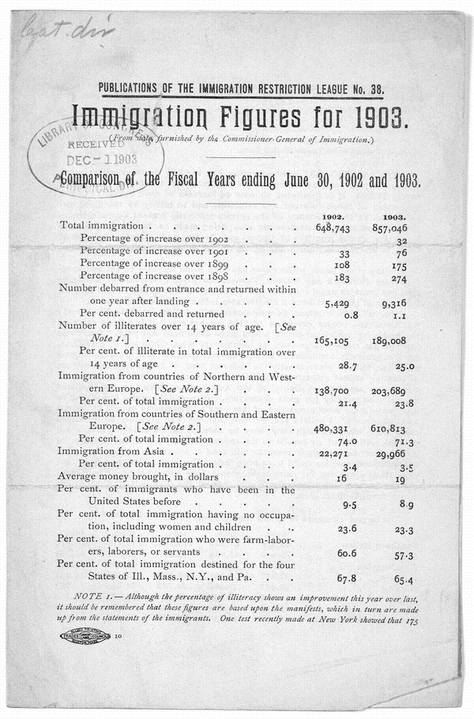 | 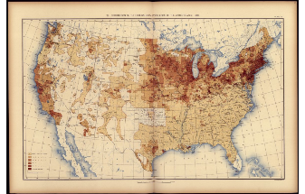 | 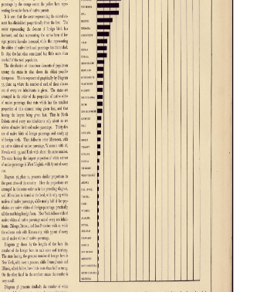
http://www.loc.gov/pictures/resource/cph.3b06393/ | http://loc.gov/pictures/resource/cph.3a40441/ | http://loc.gov/pictures/resource/pan.6a01878/ | http://memory.loc.gov/cgi-bin/query/i?ammem/rbpebib:@field%28NUMBER+@band%28rbpe+07902500%29%29 | http://www.loc.gov/resource/g3701gm.gct00010/?sp=30 | http://www.loc.gov/resource/g3701gm.gct00010/?sp=29

Distribution of those engaged in certain selected occupations, by color and nationality: 1890 | Statue of Liberty | Becoming American: Immigration and Assimilation in Late 19th Century America | Relive a Boy's Journey to America | Carte figurative et approximative représentant pour l'année 1858 les émigrants du globe, les pays dóu ils partent et ceux oú ils arrivent | Immigrants just arrived from Foreign Countries--Immigrant Building, Ellis Island, New York Harbor
Graph | Video (Edison)  c. 1898 | Seminar from National Humanities Center | Article  Copyright Milken Family Foundation | Map (French)  c. 1862 | B&W Photograph  c. 1904
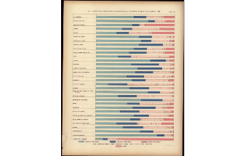 | 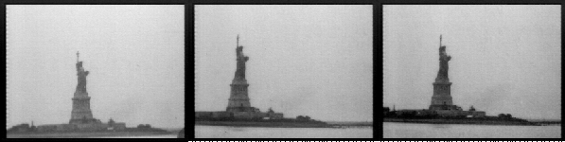 |  | 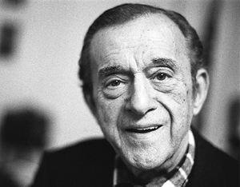 | 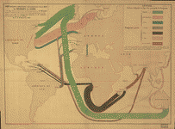 | 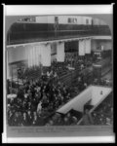
http://www.loc.gov/resource/g3701gm.gct00010/?sp=91 | http://hdl.loc.gov/loc.mbrsmi/lcmp002.m2a01604 | http://nationalhumanitiescenter.org/ows/seminarsflvs/BecomingAmerican.pdf | http://www.scholastic.com/teachers/article/relive-boys-journey | http://hdl.loc.gov/loc.gmd/g3201e.ct000242 | http://hdl.loc.gov/loc.pnp/cph.3a17784

Notes/Comments:

Phase II
Foundations Annotations
7. Curriculum Connections

Social Studies and ELA
8. Curriculum Standards

S1C1PO6 Determine the credibility and bias of primary and secondary sources.
S1C7PO1 Examine the reasons why people emigrated from their homelands to settle in the United States during the late 19th century
S1C7PO2 Describe how the United States was positively and negatively affected by factors and events resulting from the arrival of a large number of immigrants
S1C7PO4 Discuss the relationship between immigration and industrialization.
S4C1PO3 Interpret maps, charts and geographic databases using geographic information.
S4C3PO2 Describe the push and pull factors that cause human migrations.
S4C3PO3 Describe the effects of human migration in the U.S. and regions of the world.
9. Content & Thinking Objectives

SWBAT identify immigration patterns to the United States in the late 19th and early 20th century.
SWBAT analyze the push/pull factors that influenced people to immigrate to the United States
SWBAT evaluate the effect of immigrants on the culture of the United States (melting pot)
10. Inquiry Activities & Strategies

Students, having read a basic overview of the immigration to the United States in the late 1800s and early 1900s, will examine primary sources to help them answer the essential question of why people move from one place to another. Using these resources, students will identify immigration patterns, look for push/pull factors, and evaluate the effect these immigrants have on the culture of the United States. Resources include documents, photographs, videos, maps, and graphs.

11. Assessment Strategies

Students will write a short response answering the final question, evaluating the effect of immigrants on the culture of the United States.

Other Resources
12. Web Resources

13. Secondary Sources

Textbook reading
14. Print and Other Media Resources

ARS Component Guide
Phase I Components
- Title / Content Area: Provide the title of the ARS. If the title doesn’t explicitly denote the sets theme, please also provide a content area (e.g. Environment, Government, Immigration, War/Military, Women’s History, etc.).
- Developed by: Provide your name and any other contributors to the ARS.
- Grade Level: Provide the grade level(s) for which the set is to be taught.
- Essential Question: Provide an essential question that encompasses the set theme and that could be used as a launching point for use in the classroom.
- Geographic Thinking Skill(s): Identify no more than 3 geographic thinking skills that will be used in conjunction with the items in the ARS
- Contextual Paragraph for Resource Set: Provide a short paragraph explaining the resource set and describing the context in which the set is to be used. Be sure to include a geographic perspective in this paragraph.
- Resource Set: Provide titles, context, thumbnails and addresses for specific resources. It isn’t necessary to provide a thumbnail for all resources (e.g. audio and video files). Important: Be sure to use a permanent URL and check your hyperlinks for all resources.

Phase II Components
- Curriculum Standards: Provide local, state or national standards that could be addressed through the use of the ARS and subsequent activities

- Curriculum Connections: Provide other curriculum areas to which this set of resources could be applied

- Content & Thinking Objectives: Provide objectives to be met through the use of the ARS and subsequent activities

- Inquiry Activities & Strategies: Provide specific strategies and learning activities which the ARS will be used to support

- Assessment Strategies: Provide assessment methods which will be used to demonstrate student learning after the use of the ARS and subsequent activities

Other Resources
- Secondary Sources: Provide any secondary sources that could be used to supplement the ARS

- Web Resources: Provide links to any additional web resources that could be used to supplement the ARS

- Print and Other Media Resources: Provide other resources that could be used to supplement the ARS

